Machine Learning Algorithms

Supervised Learning
- Learning from data labelled with the “right answers”
- Regression
  - Predicting any number from an infinitely many possible outputs
- Classification
  - Predict the category from a small number of possible outputs
  - Presence of 2 or more inputs
    - Uses boundary line to divide outputs into different categories.
    - Output category is determined on which area the input variables falls in

Unsupervised Learning
- Find structure in unlabelled data
- Clustering Algorithm
  - Clustering is used when the data cannot be grouped as it has no given output. Hence, the algorithm tries to automatically group them into clusters
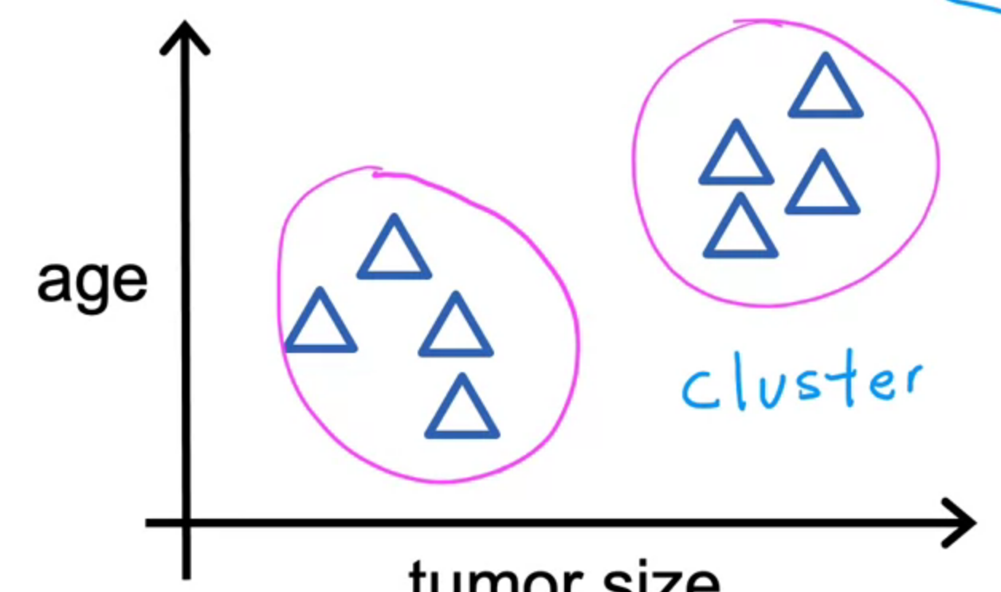
  - Different from classification
    - Classification is used when data can be grouped on their given output
    - Eg.
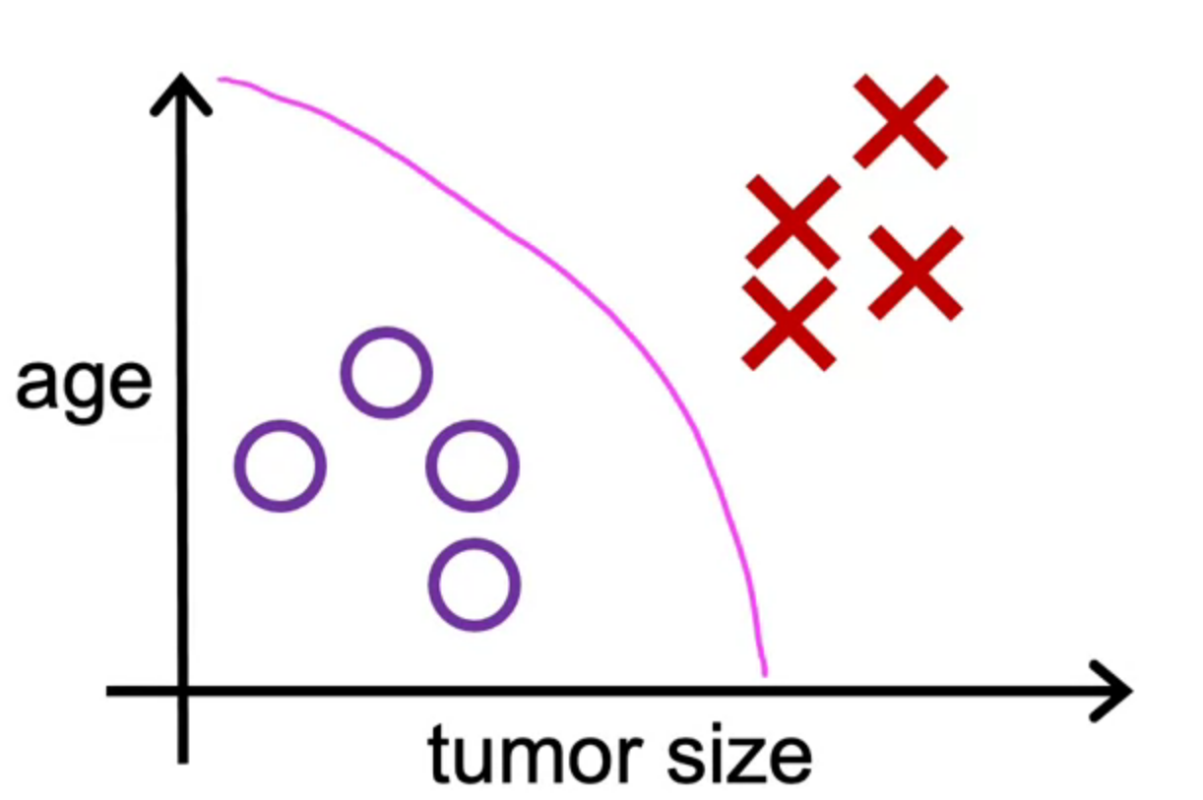
X: Cancerous tumor
O: Benign tumor
- Anomaly Detection
  - Finding unusual data points
- Dimensionality Reduction
  - Compressing data using fewer numbers

Terminology
- Training set: Data used to train the model
- x = input variable feature
- y = output/ target variable
- $\hat{y}$ = predicted y
- m = number of t raining example
- (x, y) = simple training example
- ($x^{th}$, $y^{th}$) = $i^{th}$ training example

Regression
- Linear
  - Cost Function
    - aka Squared Error Cost Function
      - $J\left(w,b\right)=\frac{1}{2m}\sum_{i=1}^{m}{{({\hat{y}}^{i} - y^{i})}^{2}}$
        - Can remove the 2 from $\frac{1}{2m}$
          - The ‘2’ serves to make final output look better
        - ${({\hat{y}}^{i} - y^{i})}^{2}$ is squared to ensure that there is a minimum value
    - Visualization
      - 3D Surface Map
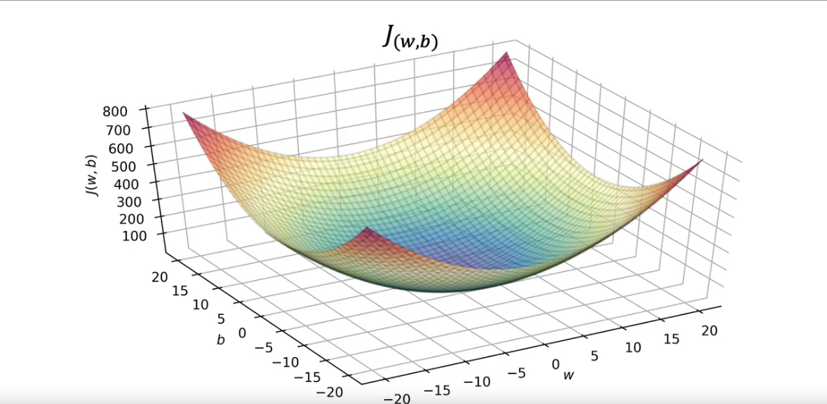
        - Length & Breadth = w & b
        - Height = Value of J
      - Contour Map
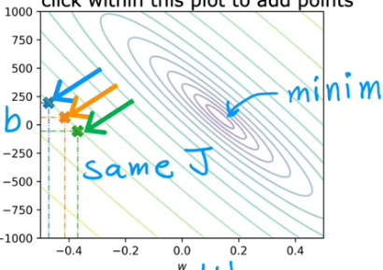
        - Length & Breadth = w & b
        - Height = Value of J
        - The smaller the gaps between the lines, the lower the height of J
        - Values of J that fall on the same line (blue, orange, green) share the same value, even if w & b differs

Gradient Descend

